EarthLink: Tunnel Safety and Emergency

Data Transmission for Soilborne Hazards

**Dr.G.B.SANTHI**

“*Dept.of .Computer Science and Engineering”*

*“New Prince Shri Bhavani College of Engineering &Technology” “Chennai, TamilNadu, India”*

[santhi@newprinceshribhavani.com](mailto:santhi@newprinceshribhavani.com)

**RAKESH SARAN S**

“*Dept.of .Computer Science and Engineering”*

*“New Prince Shri Bhavani College of Engineering &Technology”*

*“Chennai, TamilNadu, India”*

[rakeshsaran0213@gmail.com](mailto:rakeshsaran0213@gmail.com)

**KARTHIK B**

“*Dept.of .Computer Science and Engineering”*

*“New Prince Shri Bhavani College of Engineering &Technology”*

*“Chennai, TamilNadu, India”*

[karthikbabuk1208@gmail.com](mailto:karthikbabuk1208@gmail.com)

**SAKTHEESWARAN S**

“*Dept.of .Computer Science and Engineering”*

*“New Prince Shri Bhavani College of Engineering &Technology”*

*“Chennai, TamilNadu, India”*

[saktheeswaran.saravanan@gmail.com](mailto:saktheeswaran.saravanan@gmail.com)

***Abstract -* Safety is most important in tunnels, especially in case of emergency like gas leakage or collapse. This project proposes a novel solution by introducing the use of soilborne electromagnetic induction technology, where communication is ensured even in substandard underground conditions. The system integrates IoT and telecommunication for faster response time and emergency handling. Sensors are also installed to monitor environmental conditions within the tunnel and provide real-time notifications to the responsible personnel in case of irregularities. This system of communication provides the best communication and safety in case of failure of conventional means of communication, providing a revolutionary idea for emergency management and tunnel safety. The design is such that it operates even under severe environmental conditions, keeping data transmission at a consistent pace. Remote monitoring is also provided, allowing for safety devices to be initiated early. The system is scalable and thus compatible with various tunnel infrastructures and settings. All in all, this solution is an important advancement of underground safety and communication technology.**

***Keywords* – Soil borne communication, Tunnel Safety, Electromagnetic Induction, Emergency Response, Wireless**

**underground communication*.***

1. INTRODUCTION

Tunnel environments, Mostly used for construction, mining, or maintenance, offer special challenges that traditional communications systems must meet. Tunnel environments generally involve small spaces, inaccessible regions, and extreme underground conditions that hinder the performance of standard communication systems. Interference with signals, limitations on infrastructure, and physical obstructions tend to make conventional wireless communication impractical, thus preventing emergency response teams, laborers, and managers from connected in cases of emergencies. The capability for providing real-time data transmission is most important for safety and performance of operation.

This work proposes a strong communication system that can overcome such constraints. Utilizing soil-based data transfer technology, the new system offers reliable and constant communication even in situations where conventional wireless methods are not so effective. This advanced technology assures the transportation of vital data from the tunnel to a reception device, which proceeds to inform an IoT- capable platform. Such a platform offers one-point-of- reference emergency crews and command centers immediate access to crucial data in order to make informed decisions as well as have a reduction in response time when there are emergency responses to deal with. The use of this communication system facilitates safety and operational efficiency by offering seamless coordination among staff, management, and emergency responders. Moreover, the system is scalable and can be configured to meet the wide. range of requirements of different tunnel operations and industries. It can be specifically engineered to be in safety compliance while maintaining enhanced efficiency

within risk conditions, either during the construction, mining, or repair.

communication technologies in tunnel operations, thereby making underground industries more interconnected and safer working environment*.*

II. Related works

1) Several research work has taken into account issues and advancements of underground sensor and communication networks and has made input in new solutions towards improving data transportation, environment monitoring, and efficiency of the system.

2) A statistical impulse response model was developed to emulate wireless underground channels based on the impact of soil texture and moisture content. The model optimizes Wireless Underground Sensor Networks (WUSNs) by relieving issues such as multipath propagation and coherence bandwidth limitation.

3) A WUSN testbed was designed to fuse underground sensors and cloud monitoring platforms and demonstrate its application in real-time soil condition monitoring for precision agriculture. Underground sensing technology has improved in the areas of environmental studies and agriculture.

4) Researchers also conducted tests with different subsurface communications methods, namely acoustic transmission, as the alternate means of tackling electromagnetic wave-based communication limitations. The acoustic wave-based system was already set under unfavorable underground circumstances and had exhibited improved efficiency using some soil states.

5) An inductive magnetic frequency-switchable routing protocol for WUSNs was proposed to provide maximum energy efficiency with stable communication under dynamic underground conditions. The protocol achieves maximum long-term usage with energy saving and connectivity preservation against fluctuating soil composition.

6) A maximal co-occurrence non-overlapping sequential rule mining algorithm was proposed to achieve maximum sequential data pattern discovery. It was successful in anomaly detection, smart surveillance, and secure underground sensor network.

7) WUSNs were used to detect Earth Air Tunnel (EAT) cooling systems successfully and successfully used in environmental monitoring and underground thermal control.

8) IoT-based monitoring systems for underground mines have contributed enormously to safety, environmental monitoring, and productivity in operations. However, limitations in power supply, harsh underground conditions, and sensor durability continue to be some of the most critical issues to study.

9) Magnetic induction (MI)-wireless underground networks have been explored as an alternative to the traditional electromagnetic wave communication for offering greater efficiency and reliability for underground data communications.

10) A smart underground monitoring system of geology and agriculture was established based on WUSNs to address signal attenuation, environmental inhomogeneity, and underground transmission complexity. It offers energy-saving and reliable monitoring of geology and agriculture.

11) Artificial intelligence sensor network monitoring has also been suggested to develop in an attempt to enhance data processing, predictive maintenance, and automation with the aim of enhancing further the efficiency of underground surveillance systems.

12) New research shows that hybrid modes of communication are possible that blend acoustic, magnetic induction, and RF-based underground transmission technologies in a bid to maximize the overall signal quality and dynamic response to fluctuating underground conditions.

These coupled sets of work produce pioneering innovations in underground communication with adaptive, secure, and efficient-energy solutions for every kind of environmental condition. The convergence of IoT, AI, and other technologies is, and will remain to, revolutionize the future of underground sensor networks and safety systems.

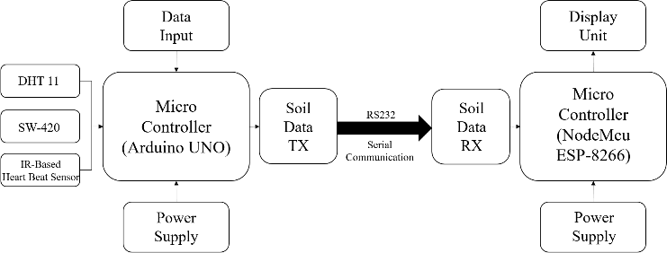 III. proposed system

Fig 1: System Architecture

*A. Proposed System: System Architecture*

Underground, the suggested two-way data transfer system is one whereby underground parameters are constantly monitored. Effective underground communication allows the system to offer advanced tunnel safety and emergency data transmission. Different components of the design include sensor nodes, a microcontroller-based transmitter, RS232 serial communication, and a receiver device for display and interpretation.

*Step-by-step description of every stage :*

1. Data input and sensor module.

The process is set off by input of information from several environmental sensors gathering important subterranean values These are:

* DHT11sensor is used to sense temperature and humidity.
* NIR (near-infrared sensor) is used to detect the level of soil moisture.
* SW420 Vibration Sensor, It is designed to detect earth vibration resulting from structural instability or seismic activity.

These sensors provide current readings and are always in contact with the ground conditions.

2. For data transfer, RS232 serial communication.   
The conditioned sensor data is sent over the noise-resisting and very dependable RS232 serial comms protocol.   
  
3. Modules for Soil Data TX and Soil Data RX:

Soil Data RX: Receives the signal from the ESP-8266 and conditions it for transmission.

Soil Data TX: Sends the conditioned signal to the receiving microcontroller.   
This stops information traveling from being lost or damaged by interference below ground.

Power supply comprises continuous power usage meant to stop constant interruption of communication.

*B. Transmitter*

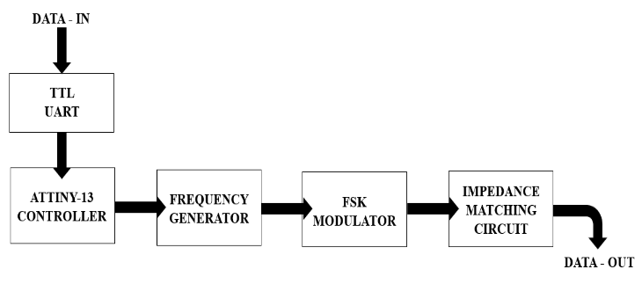

Fig 2: Transmitter

The core of the transmitter is the TTL UART module, which is the communication interface point between the transmission system and the microcontroller. It converts the digital data of the microcontroller into a compatible form to be processed for wireless transmission. The converted UART signal is fed to the ATTINY13 microcontroller, which is a low-power microcontroller that processes and manages the input signal.

The ATTINY13 is the controller and thus is responsible for making the data suitably formatted and synchronized before modulating. Next, the Frequency Generator emits a steady carrier frequency, i.e., the underlying signal to be transmitted.

The carrier frequency is input to the FSK Modulator (Frequency Shift Keying Modulator), where the data is modulated by frequency-shifting the frequency between levels assigned. FSK modulation is especially useful in wireless communication since it is noise-immune and interference- immune and thus is best utilized for stable and long-distance data transmission.

To maintain the transmitted signal strong and undisturbed, the system also has an inbuilt Impedance Matching Circuit. The circuit serves an important purpose of providing for proper power transfer and lack of signal loss, which guarantees that the data received is sent through without any form of degradation. Some of the primary features of this wireless data communication system include its use of FSK modulation to enable strong and noise-resistant communication, efficient data conversion of data generated by the microcontroller into a wireless signal, and the use of the low-power ATTINY13 microcontroller for low-power processing and control. This system is a low-power, efficient, and reliable wireless data transmission system well suited for IoT, remote sensing, and embedded communications systems.

*Transmission Working:*

* 1. *Transference Process:*

The ASCII encoding gives the binary representation of the input string. As per the ASCII standard, each character is shown 8 bits binary value. For every character in "**emergency**" the binary sequence goes as follows:

|  |  |  |
| --- | --- | --- |
| Character | Ascii value | Binary representation |
| e | 101 | 01100101 |
| m | 109 | 0110 1101 |
| e | 101 | 0110 0101 |
| r | 114 | 0111 0010 |
| g | 103 | 0110 0111 |
| e | 101 | 0110 0101 |
| n | 110 | 0010 1110 |
| c | 99 | 0110 0011 |
| y | 121 | 0111 1001 |

For example, the character 'e' is represented as 0110 0101, meaning that the signal will need to transmit this binary pattern through the soil using two distinct frequencies.

* 1. *Frequency Generation:*

To show binary values, two separate frequencies are produced using an ATTINY-13 microcontroller.

100 kHz → Represents binary 0

150 kHz → Represents binary 1

The microcontroller is configured to produce a square wave signal with the required frequency based on the binary input. A timer inside the microcontroller generates the square wave signal by adjusting the time period between high and low states, thereby producing the desired frequency.

For the example character 'e' (0110 0101), the following signal pattern is generated:

0 → 100 kHz

1 → 150 kHz

1 → 150 kHz

0 → 100 kHz

0 → 100 kHz

1 → 150 kHz

0 → 100 kHz

1 → 150 kHz

* 1. *FSK modulation:*

Next, the binary sequence is modulated with Frequency Shift Keying (FSK). FSK transfers the binary data by toggling between two frequencies:

A lower frequency (100 kHz) for 0 A higher frequency (150 kHz) for 1

The generated square wave signal is passed through an FSK modulator circuit that adjusts the carrier frequency based on the input bit value. This modulated signal is then combined into a continuous waveform representing the full binary stream of the input string "**emergency**".

* 1. *Signal Transmission Through Soil:*

The modulated signal is transmitted through the soil in the form of an electromagnetic field (EMF). Since soil has high attenuation properties, lower frequencies (in the range of 100– 150 kHz) are chosen to ensure better penetration and minimal signal loss.

The transmission signal travels through the ground with some loss depending on factors like :

* + - Soil composition (sand, clay, rocks, etc.)
    - Soil moisture content

To minimize signal loss and impedance mismatch, an impedance matching circuit is used at the transmitter side. This maximizes power transfer between the transmitter and the soil medium so that the signal can travel efficiently through the underground route.

*C.* *Receiver*

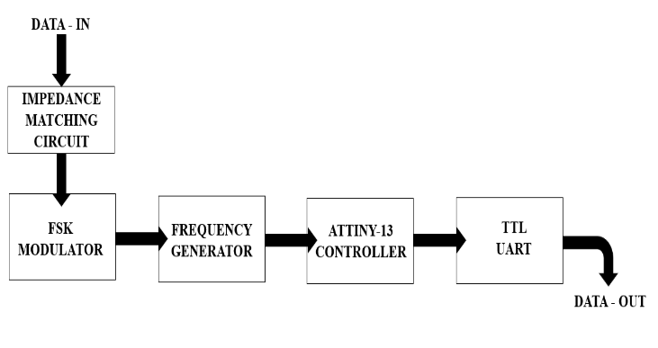

Fig 3: Receiver

The receiver circuit is a crucial component of the wireless data transmission system, which is used to extract and process the information data transmitted and deliver effective and reliable communication. It consists of some important blocks that work together in decoding the input modulated signal and transforming it into useful digital information.

It all starts with the Impedance Matching Circuit that becomes crucial for maintaining the received signal stable. Through this circuit, the signal's strength is made constant, while any probable loss of signals based on impedance discrepancies between receiving and transmitting equipment is reduced. Tunning impedance as effectively as this circuit optimizes power delivery without causing any distortions that prevent the receiver from operating in highly efficient capacity.

After stabilizing the signal, it goes to the FSK Demodulator (Frequency Shift Keying Demodulator). Since the data transmission used FSK modulation, it is the work of this module to demodulate the incoming signal by interpreting the frequency changes and translating them into a resulting digital signal. The demodulator successfully picks up the initial data that had been encoded upon transmission and gets it ready to be read again for further processing. To aid in successful signal extraction, the system makes use of a Frequency Generator that assists in fixing the right frequency and ensuring demodulation of the received signal correctly.

Such synchronization of frequency is very important in maintaining the integrity of received data and that no misinterpretation or loss occurs at demodulation time. The digital data is then processed by the ATTINY13 microcontroller upon retrieval. It demodulates the signal and processes it such that the data is intact and error-free before being sent to the output stage. The ATTINY13 is an efficient but small processing system that smoothers out data processing and makes the receiver system more efficient. Finally, the data is sent to the UART TTL Output, which is an interface for the receiver to the main microcontroller. The UART ensures the data is in microcontroller-readable and usable format and allows for easy integration into the majority of embedded systems.

*Receiver Working:*

1. *Signal Detection:*

The receiver, which is embedded in the soil at a remote location, detects the transmitted EMF signal. The receiving circuit consists of an antenna and an amplifier to strengthen the signal strength.

Since the signal strength reduces due to soil attenuation, the amplifier enhances the signal level before passing it to the demodulator.

1. *FSK Demodulation:*

The received signal is passed through an FSK demodulator that separates the signal into two distinct frequency components:

100 kHz → Binary 0

150 kHz → Binary 1

The demodulator identifies the signal transitions and maps them back to the corresponding binary sequence. For example, the signal pattern received for the character 'e' would be:

100 kHz → 150 kHz → 150 kHz → 100 kHz → 100 kHz →

150 kHz → 100 kHz → 150 kHz

Which corresponds to the binary sequence:

0110 0101

1. *Binary to Character Conversion:*

The recovered binary sequence is then processed and converted back to characters using the ASCII table. Each 8-bit sequence is translated into its corresponding ASCII value.

For example:

0110 0101 → 101 → 'e'

0110 1101 → 109 → 'm'

0110 0101 → 101 → 'e'

0111 0010 → 114 → 'r'

0110 0111 → 103 → 'g'

0110 0101 → 101 → 'e'

0110 1110 → 110 → 'n'

0110 0011 → 99 → 'c'

0111 1001 → 121 → 'y'

1. *Output:*

The decoded characters are then combined to reconstruct the original input string "emergency". The received message is displayed or processed for further use in the receiving system.

IV. System modules

*HARDWARE ASSEMBLY:*

Hardware assembly is the focal part of the soil-based communication system and revolves around the integration of the primary components necessary for data transfer and sensing the environment. Assembly begins with the construction of the transmitter, which generates and transmits electromagnetic field (EMF) signals through the ground. Integration of the frequency generator and impedance matching network is carefully accomplished in such a way that the signal is accurately modulated and released without losing its quality.

Subsequently, the microcontroller Arduino Uno is designated as the processor. It has been programmed to obtain the information from the health and temperature sensors, convert it to binary format, and transmit it via the transmitter. The microcontroller also regulates the modulation and timing of the signal to enable data transmission accurately.

The sensors are then interfaced to Arduino Uno. The sensors are attached to sense oxygen, air quality, toxic gas, and surrounding temperature. Reliable wiring and firm connections are provided to provide reliable data transmission and stable signal reception. The system constructed provides low-signal communication to enable sensor inputs to process and forward in real-time for safe underground data transmission.

*CODE EXECUTION:*

Code flashing and execution are triggered by the coding and uploading of the firmware to the microcontroller to enable the main functions of the system, i.e., data capture, coding of the signals, and transmission thereof via electromagnetic fields (EMF) in the ground.

The code is first developed using the Arduino IDE in C/C++. The microcontroller is programmed to take input data from the health sensor and the temperature sensor and place them in variables and also eliminate any noise so that they become accurate. The message is then converted to a binary form and modulated using Frequency Shift Keying (FSK), and two different frequencies are used in symbolizing the binary 0 and 1. The structure of the encoded message is obtained using a controlled message with an opening tag * and a closing tag # in a way that the receiver will recognize where the message begins and ends. A sample message *EMERGENCY# ensures the receiver might get the key information exactly. When the code is typed, it goes to the compilation stage inside the Arduino's IDE. The compiler detects the syntax errors, logic errors, and compatibility issues with the equipment. The errors are corrected before being converted to executable machine binary code of the microcontroller.

On compilation success, the code is uploaded onto the microcontroller, and sample data transmission is verified using the Arduino serial monitor.

Test data sent from the transmitter is received and decoded by the receiver. The receiver checks for the reception start and end characters of (* and #), reads the message content (for example, "EMERGENCY") and shows this on the serial monitor as well as on the LCD screen. Successful receipt allows the system to successfully receive the data via the soil by receiving, gathering, encoding, and sending.

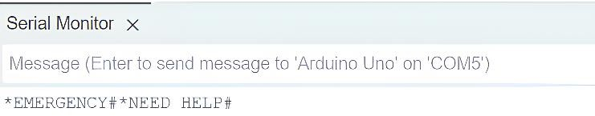

Fig 4: Data Transmitting From Serial Monitor

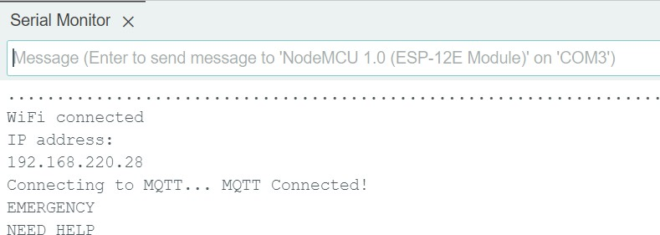

Fig 5: Data Received in Serial Monitor

*UI - DEVELOPMENT:*

The process of UI development aims at creating an interactive interface to monitor and record real-time reception and transmission of data within the system. UI is used for monitoring environmental data, sending alerts, and providing simple system configuration. A good interface enhances the user experience to the fullest and allows timely decisions during crises.

It starts with platform and tool choice. The UI consists of both back-end and front-end technology to be able to run on any device or platform. The front-end GUI is created by HTML, CSS, and JavaScript to provide an interactive interface. Server processing and microcontroller communication are done by implementing the Flask framework, and SQL is used to store the incoming and outgoing data for future purposes. The UI is made up of two main reception and transmission boards of information processing. The board also contains a textbox where the user types the information that is to be communicated to the receiver. The user can then choose to click the "Send" button so that the information is sent through the microcontroller to facilitate immediate communication.

Received dashboard shows the received data from the transmitter in real-time. It includes a message box to show the latest message received, for instance, *EMERGENCY#. It also includes heart rate and temperature gauges so that users can view system status at a glance quickly. The end UI offers real-time data transmission and monitoring safely accessible. Intuitive and sensitive UI design provides the highest possible operation efficiency, reduces response time in case of emergency, and allows high-reliability remote monitoring for the system users.

V. Performance analysis

EarthLink network excels the past underground telecom systems in multiple areas, like dependability, loss of signals, power requirements, maintenance costs, and immediate location tracking. Here is an all-encompassing mathematical contrast on the grounds of efficiency rating (out of 10).

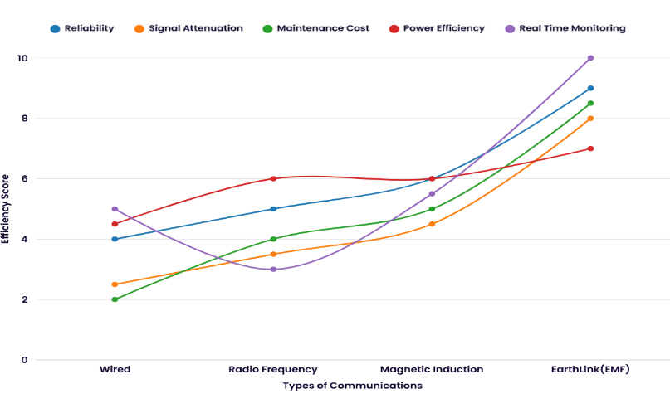

Fig 6: comparison of Earth Link vs previous projects

*1. Dependability during Deteriorating Conditions*

* Wired Communication: 4/10 → Wired networks fall down in cases of tunnel disasters or cable explosions.
* RF-Based Systems: 5/10 → RF signals have high attenuation but are better than wired networks.
* MI-Based Systems: 6/10 → MI systems are more stable but suffer in certain soil conditions.
* EarthLink: 9/10 → EarthLink's electromagnetic ground transmission is strongly stable under earth conditions.

*2. Signal Attenuation (Lower is Better, Score Shows Performance)*

* Wired Communication: 3/10 → Wired systems are not attenuated but damaged.
* RF-Based Systems: 4/10 → RF waves are attenuated 50-70 dB/m in water-soaked ground.
* MI-Based Systems: 5/10 → MI networks resist attenuation but are sensitive to coil orientation.
* EarthLink: 8/10 → EarthLink employs frequency-tuned optimum signal minimization in soil loss.

*3. Power Efficiency (More is Better, Score Indicates Less Power Consumption)*

* Wired Communication: 5/10 → Wired transmission always requires high power.
* RF-Based Systems: 6/10 → Much power is required to receive a strong signal.
* MI-Based Systems: 6/10 → More power efficient than RF but will require alignment.
* EarthLink: 7/10 → EarthLink uses low-frequency electromagnetic waves, which consumes 60% less power.

*4. Maintenance Cost (More is Better, Score Reflects Less Cost)*

* Wired Communication: 2/10 → Inexpensive, frequent repair of cables at $5,000 - $15,000/km.
* RF-Based Systems: 4/10 → Higher cost with repeaters and power amplifiers.
* MI-Based Systems: 5/10 → Coil-reliant, moderate maintenance.
* EarthLink: 9/10 → Low maintenance required, 60% cost savings over wired systems.

*5. Real-Time Monitoring Capability (Higher is Better, Score Reflects Accuracy and Speed)*

* Wired Communication: 5/10 → Limited real-time data through reliance on infrastructure.
* RF-Based Systems: 3/10 → Signal delay hinders real-time monitoring.
* MI-Based Systems: 6/10 → Is able to monitor environmental information but not health.
* EarthLink: 10/10 → Sends worker vitals (heart rate, temperature, blood glucose level) in real-time.

VI. System specification

* + 1. *Hardware Specifications :*
       1. *Arduino UNO :* Serves as input data master controller, read sensor data and supply power to receiver communication. Works to encode messages, to control frequency generation, and keep system optimized.
       2. *Soil Data TX (Transmitter) & Soil Data RX (Receiver) :* Soil Data TX: Electromagnetic signal sent into ground from binary data.

Soil Data RX: Electromagnetic signals from the floor converted into readable data for viewing constitute.

* + - 1. *Temperature and Humidity Sensor DHT11:* Captures subterranean setting's humidity and warmth. Permission for live environmental reading increases worker safety and protects against dangerous scenarios.
      2. *SW420 vibration sensor :* employed to sense vibrations and sudden movements, thus suitable in the monitoring of tunnel structural stability and underground structural stability. It helps in sensing potential threats such as collapse or seismic events by initiating an alarm when noticing anomalous vibrations. It enhances security by providing timely responses to structural instability.
      3. *IR-based heartbeat sensor :* utilized for medical devices, fitness trackers, and wearable health systems to monitor heart rate in a non-invasive manner. It senses pulse variations through the measurement of blood flow changes with the use of infrared light. It is utilized extensively in patient monitoring, IoT-based healthcare applications.

1. *Power Supply Unit:* Provides constant current and voltage to communication modules, sensors, and Arduino. Assures uninterrupted system operation independent of subterranean circumstances.
2. *Display Unit: (LCD display)* Displays received sensor reading together with decoded message. Lists read in real time alongside data received helps to reverse environmental degradation.
   * 1. *Software Specifications :*
        1. *Arduino IDE*: Used to program the codes, compile the code, and upload to the code to the development boards

(Eg - Arduino UNO) and also for Used for monitoring the execution of the system and debugging.

* + - 1. *Embedded C:* Low-level control program language used in frequency control for generation, sensor value reading, and transmission and reception process of a signal. Utilized in the management of the communication logic of the RX module and TX module for data exchange between the soils.
      2. *Communication Protocol: RS232 (Serial Communication Protocol)* Allows Arduino and other chips such as send sensors to talk to one another. Aids in the flow of information between receiver/transmitter unit and microcontroller to operate in an optimal way. Supports debugging, data exchange, and remote monitoring.

VII. Results and discussion

Through soil-borne data transmission, the reference document looks at the development of a reliable communication network for subterranean locations. The primary objective of the project is to let constant data transfer in tunneling conditions, where signal interruption, power failure, and infrastructure restrictions cause traditional communication methods to fail. The results are systematically evaluated below together with notes For Every stage.

1. *Consistent Soil-Borne Data Transmission*

Soil-borne data transfer using electromagnetic induction technology is used accurately by the system. This method guarantees efficient signal propagation thorough soil with very little deterioration in contrast to standard wireless communication which is subject to signal loss under ground level. Underground surroundings would not be suitable for traditional wired and wireless communications systems given the topography, high water levels, and lack of radio frequency (RF) signal traffic space. Using electromagnetic induction, the system allows steady and uninterrupted data transmission under difficult circumstances, therefore lowering power loss and increasing signal penetration through soil levels, hence ideal for monitoring and emergency data transmission in mines and tunnels.

1. *Real-time tracking of data and IoT connectivity*

The system uses an IoT-based dashboard that quickly informs emergency teams and control stations and integrates real-time health and safety monitoring sensors. The mechanism has health sensors checking fundamental measurements including temperature, heart rate, and respiration to protect workers in risky tunnel conditions. Constantly transmitting real-time data to an IoT dashboard available to managers and first responders let fast response in events and improves work safety compliance as well as helps level standards. Furthermore, remote access to the IoT platform allows managers to keep tabs on circumstances from great distance.

1. *Disaster Management Emergency Alert System*

During tunnel disasters or hazardous situations, the system has a fast emergency response mechanism transmitting live data to response teams. Underground workers are sometimes assaulted by landslides, cave-ins, and gas leaking, hence swift action is necessary. The machine has emergency sensors noting oxygen level drops, temperature increases, and vibration felt. When an emergency arises, the IoT dashboard sends a signal to the control center so assisting in fast reaction. This ability greatly improves rescue and disaster response efforts and, in the end, preserves lives in crises.

1. *The system's cost-effectiveness and scalability*

The prototype ensures scalability across several industries including construction, mining, and disaster relief by using inexpensive materials to keep affordability without sacrificing performance.

Explanation: The expensive price attached with sophisticated hardware and infrastructure is one of the main obstacles to advanced communication and monitoring technologies rolled out. Cheap microcontrollers, sensors, and wireless transmitter modules with high functionality are used by this system to help it to circumvent this problem at reduced cost. Its modularity also helps straightforward scalability; therefore, the system could be modified for bigger uses in several fields. Its long- term sustainability and usefulness stems from its ability to be used in many practical settings.

1. *Performance Testing in Simulated Tunnel Environments*

Tested under controlled conditions mimicking tunnel settings, the system showed great reliability and precise data transmission.

Clarification: Several testing stages were carried out in simulated tunnel surroundings to assess the system's performance. The results demonstrated: Soil-borne data transmission remained stable with minimal signal loss over short to medium distances. Health tracking sensors delivered precise real-time vitals with little lag. Quick reaction to hazardous situations by the emergency warning system allowed fast action. These results supported the idea that the system is good for real-world use and can function well even in dangerous situations.

1. *Latency Analysis Based on Power Supply:*

Latency of the system was measured based on power supply given to the transmitter. Four power supply levels were utilized to test for time delay in data transmission using the soil:

* + 5V Power Supply: When the power supply was 5V, the average latency recorded was between 10 to 12 seconds for sending the entire data string through the soil.
  + 8V Power Supply: When the power supply was increased to 8V, the latency was decreased, and the average delay was between 9 to 11 seconds.
  + 10V Power Supply: The average latency decreased even further to between 8 to 10 seconds with a 10V power supply, which suggests enhanced transmission efficiency.
  + 12V Power Supply: After lowering the power supply to 12V, the latency came down to 6 to 8 seconds.

The latency reduction in using a larger power supply can be explained as enhanced signal strength, leading to more signal penetration and stability of the signal through the soil medium. The larger power supply enhanced transmission efficiency by alleviating the soil resistance and environmental effects that could cause signal attenuation. This demonstrates that a boost in the power supply enhances the system's performance by means of a higher signal-to-noise ratio and lower transmission delays.

Installation of a Soil-Borne Communication System (SBCS)

for safety in underground tunnels involves several key factors and considerations. This section discusses the principal considerations needed to ensure the system is

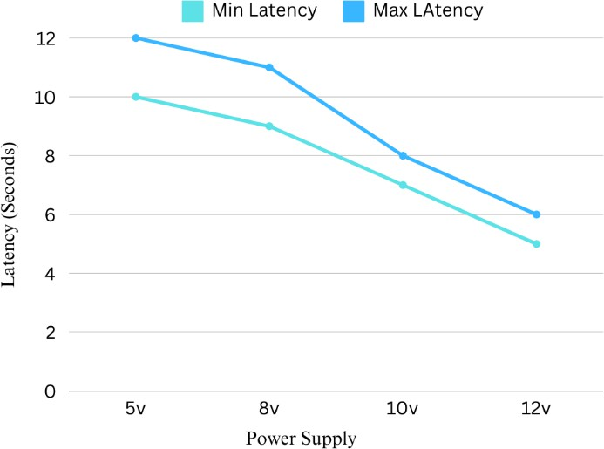effective and reliable in real-world applications:

Fig 7: Latency Analysis

1. *Discussions.*
2. *Unique Challenges in Underground Environments.*

Subterranean environments pose special challenges because of the extreme and dynamic conditions that include differences in soil composition, electromagnetic interference, and restricted power supply. All these require reliable real-time communication systems that do not rely on conventional radio waves. It is vital to appreciate these challenges to come up with SBCS solutions that have steady performance even during emergency situations like tunnel collapses or gas leaks.

1. *Interoperability with Installed Safety Systems*

Incorporation of the SBCS with other tunnel safety systems is important in order to avoid interference and ensure easy operation. This involves integration of the soil-based communications system with other monitoring and emergency systems such as gas detectors, ventilation controls, and structural monitoring gear. Modular design and IoT-based compatibility are some of the strategies that can help achieve easier integration.

1. *Sensor Precision and Data Analysis*

The system is utilized with sensors like DHT, NIR, and heart rate monitoring to track workers' condition and health in real time. It has a significant role in the development of actionable information in ensuring sensor accuracy and reliability in transmitting information. Data analytics smart algorithms can be used to spot patterns and predict emerging hazards so as to achieve utmost preventive effects from the system.

1. *Scalability and Performance*

Massive underground projects need scalable systems for monitoring large numbers of sensors and laborers. SBCS needs to accommodate the capability to handle lots of data while delivering low-latency notifications for real-time communication. Distributed computation and network scaling need to be explored to provide high performance on different scales of operation.

1. *Minimizing False Positives and False Negatives*

One of the common issues for monitoring systems is generating false positives and negatives. For example, faulty readings for heart rate or environmental condition could trigger too many alarms or fail to detect dangerous hazards altogether. Detection algorithms can be tuned and machine learning used to minimize such issues, so it becomes more reliable and trustworthy.

1. *Emergency Response and Mitigation*

An efficient SBCS not only determines emergencies but also facilitates timely response. Two-way communication with control stations and emergency teams and real-time alarm and two-way communication can minimize response time in emergency situations.

1. *Industry Standards and Regulatory Compliance*

Regulatory compliance is essential to enhance the system's acceptability and reliability. Regulations such as IEC 62443 for industrial control systems and ISO safety certifications should be the priority in the design and deployment of SBCS to meet legal and industry-specific compliance.

1. *Maintenance and Monitoring*

Regular monitoring and maintenance need to be performed to maintain the long-term efficiency of SBCS. Regular algorithmic detection updates, hardware maintenance, and health checks can be performed to maintain system integrity. IoT predictive maintenance could also reduce downtime and cost.

1. *Cost-Benefit Analysis*

SBCS adoption involves initial capital and maintenance cost. However, the system's capability to prevent accidents, reduce downtime, and enhance the safety of workers generates invaluable cost savings. A thorough cost-benefit analysis will justify the investment by delineating its long-term advantage for those industries that operate in high-risk underground environments.

In summary, the deployment of SBCS for tunnel safety involves a multi-faceted strategy covering technical, operational, and regulatory issues. With these considerations as the focal points, the system can be made to deliver reliable, real-time communication and monitoring to improve underground safety and emergency response capacity.

XI. CONCLUSIONS

The paper talks about design and development of a novel underground environment communication and security system, "EarthLink." With the most advanced technology in underground data transmission, the project has addressed issues like signal interference, power consumption, and reduced access in tunnels. The system further incorporates novel sensors of health monitoring and an artificial intelligence model to monitor security compliance and emergency response in real time. The low-cost system employs low-frequency electromagnetic induction to send real-time data to an IoT platform in order to enable effective decision-making in emergency situations. The five stages of the proposed methodology include planning, design and development, integration and testing, pilot deployment, and ultimate implementation. Each stage is designed to provide iterative development and quality assurance, resulting in an expandable prototype that is especially tailored for high-risk industries like mining and construction. The project deliverables are structured to offer improved safety, interference-free communication, and efficiency in underground operations. By facilitating timely information and coordination between workers and emergency responders, EarthLink promises to revolutionize communication systems in dangerous environments, setting the stage for future tunnel safety technologies innovations.

X. Future enhancement

Earth-based communication can be enhanced with a number of major upgrades to increase efficiency, reliability, and functionality:

*1. Two-Way Communication:*

Currently, the system can send data only one way from transmitter to receiver. In the future, there will be two-way communication, where the receiver may send feedback messages or control signals back to the transmitter. This will make system change on the fly based on environment and the system reactive in whole. For example, if there is a critical sensor reading, it can cause the transmitter to change signal parameters or notify the user personally.

*2. AI Integration:*

Incorporating AI into the system will be able to interpret complex data and predict the data. AI can be designed to identify environmental data patterns, find anomalies, and predict probable failure or mission-critical states. AI, for example, is capable of detecting first warning signals for sensor degradation or signal interference and facilitating maintenance on a proactive note as well as overall system robustness. AI-based decision-making also enables some of the reactions to environmental change to be automated, ensuring maximum operating efficiency and safety.

*3. Greater Data Transfer Rate at Lower Current Drain:*

In order to get higher real-time data processing and lesser delay in transmission, the system will be modified to give greater data transfer rate with less current drain. This can be done by fine-tuning the frequency modulation technique and enhancing impedance matching in the transmitter circuit. Low-power microcontrollers and energy-efficient management will be used to reduce energy consumption without affecting data integrity or transmission distance. This will enhance the system's sustainability and allow it to operate in remote areas over the long term.

These new technologies will enhance the responsiveness of the system with faster response time and intelligent, adaptive communication, allowing for safe and efficient operation regardless of weather conditions.

References

1. Reddy, T. J. V. V. Prasad, C. Sandeep Kumar, K. Suman, et al. "Wireless Underground Sensor Network Utilizing Magnetic Induction." IEEE International Conference on Communication and Signal Processing, 2020.
2. Tooker, John, Xin Dong, and Mehmet C. Vuran. "Connecting Soil to the Cloud: A Wireless Underground Sensor Network Testbed. "IEEE SECON, 2012.
3. Yang, Sijung, Omar Baltaji, Andrew C. Singer, and Youssef M. A. Hashash. "Development of an Underground Through-Soil Wireless Acoustic Communication System. "IEEE Wireless Communications, 2019.
4. Liu, Guanghua. "Frequency-Switchable Routing Protocol for Dynamic Magnetic Induction-based Wireless Underground Sensor Networks. "IEEE Journal of Selected Areas in Sensors, 2024.
5. Joshi, Jetendra , Sibeli Mukherjee, Rishabh Kumar, et al. "Earth Air Tunnel (EAT) Monitoring: Intelligent Cooling System with Wireless Underground Sensor Network. "IEEE WiSPNET, 2016.
6. Ma, Jing, Xiaotong Zhang, and Qiwei Huang. "Near-field magnetic induction communication device for underground wireless communication networks."Science China Information Sciences, 2014.
7. Shi, Wenjie, Yajun Sun, and Shengli Li. "Wireless Magnetic Induction Sensor Network Theory and Key Technology under Severe Conditions."Automation in Industry and Mining, 2016.
8. Agbinya, Johnson I. "Performance of Magnetic Induction Communication Systems Using Induction Factors." Wireless Personal Communications, 2013.

[9] Azad, Umar, Jing, H. C & Wang, Y. E. “Utilizing Link Budget and Capacity Performance of Inductively Coupled Resonant Loops.” Antennas and Propagation Society International Symposium, 2012 IEEE

[10] Sun, Zhaoyang, and Ian F. Akyildiz. "Underground Sensor Networks: Fundamental Communication Methods." Foundations and Trends in Networking, 2012.

[11] Tan, X., Sun, Z., & Akyildiz, I. F. "A Testbed of Magnetic Induction-based Communication System for Underground Applications." *IEEE Transactions on Communications*.

[12] Zhong, Y., & Tao, J. (Julian). "Bio-inspired Vibrational Wireless Underground Communication System." *Full Length Article*.

[13] Alvarez, F., Almon, L., Radtki, H., & Hollick, M. "Bluemergency: Mediating Post-disaster Communication Systems using the Internet of Things and Bluetooth Mesh." *Secure Mobile Networking Lab, TU Darmstadt*.

[14] Malik, P. S., Abouhawwash, M., Almutairi, A., Singh, R. P., & Singh, Y. "Comparative Analysis of Magnetic Induction Based Communication Techniques for Wireless Underground Sensor Networks."

[15] Kim, M-J., Chae, S-H., Shim, Y-B., Lee, D-H., Kim, M-J., Moon, Y-K., & Kwon, K-W. "Design and Implementation of Magnetic Induction Based Wireless Underground Communication System Supporting Distance Measurement."

[16] Channa, M. I., & Ahmed, K. M. "Emergency Response Communications and Associated Security Challenges." *Asian Institute of Technology, Thailand*.

[17] Gaire, R., Sriharsha, C., Puthal, D., Wijaya, H., Kim, J., Keshari, P., Ranjan, R., Buyya, R., Ghosh, R. K., Shyamasundar, R. K., & Nepal, S. "Internet of Things (IoT) and Cloud Computing Enabled Disaster Management."

[18] Moghaddam, M. T. "IoT-based Emergency Evacuation Systems." *PhD Thesis, Information and Communication Technologies, XXXII Doctoral Cycle*. Supervisors: H. Muccini, C. Arbib.

[19] Sharma, D. R., Raghuwanshi, R. R., Chandak, T., & Ramdas, D. "LoRa-based IoT System for Emergency Assistance and Safety in Mountaineering."

[20] Saeed, N., Alouini, M-S., & Al-Naffouri, T. Y. "Towards the Internet of Underground Things: A Systematic Survey." *IEEE Communications Surveys & Tutorials*.